**Walking a Labyrinth**

“The prayerful longing of one’s heart— to love, to connect to community, and—even in the smallest of ways—to make a footprint in this world, with integrity and pure hearted intention—magnetizes the forcefield.”

-Lauren Artress, *The Path of The Holy Fool:*

*How the Labyrinth Ignites Our Visionary Powers*

Labyrinths provide for walking meditation or prayer. Unlike a maze with ways to trick you, labyrinths have a single guided path to follow, one step at a time, toward the center, and return on the same path. There are many ways to experience the labyrinth and each person may have a different experience each time they walk one. There is no right way and no wrong way to experience the labyrinth. Here are some basic guidelines:

While walking in toward the center:

* **Release**—let go of the details of your life…empty your thoughts and emotions…walk with an open heart.
* **Rest**—as you arrive at the center…remain as long as you like…be open to receive what is there for you…perhaps offer a prayer or meditation…breathe deeply.
* **Return**—as you leave the center and walk out of the labyrinth…rejoin your community with fullness, peacefulness, or with the healing forces at work…go in peace…trust that you are not alone. God is with you on the journey.

“More than upholding religious beliefs, spiritual practices develop humility, practice surrender, and quiet our pounding hearts and chattering minds. Contemplative practices strengthen our capacity for deeper awareness. Walking labyrinths clears the mirror of the soul; through community we can piece together the shards of humanity broken so long ago.”

-Lauren Artress, *The Path of The Holy Fool:*

*How the Labyrinth Ignites Our Visionary Powers*

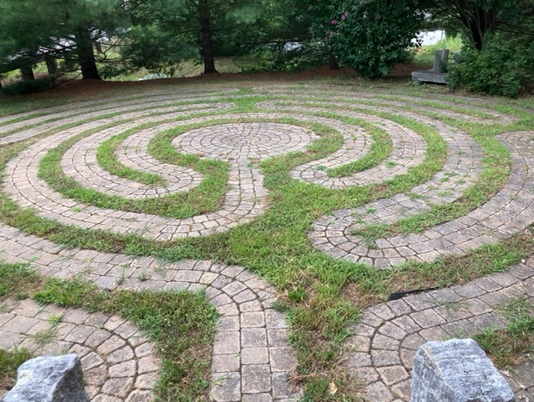

Medieval 6- circuit Labyrinth,

Eastern Connecticut State University, Willimantic, CT

Lavender Labyrinth, Jefferson, MA

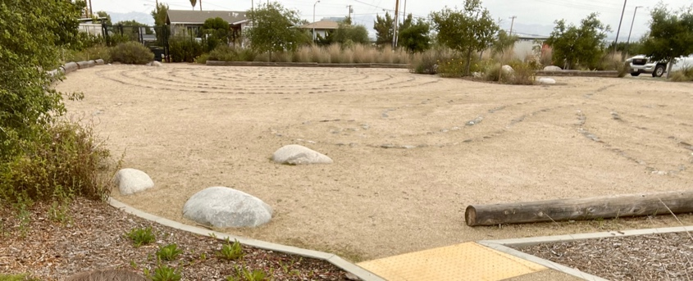

Classical 7-circuit and Tree of Life Labyrinth, Culver City, CA

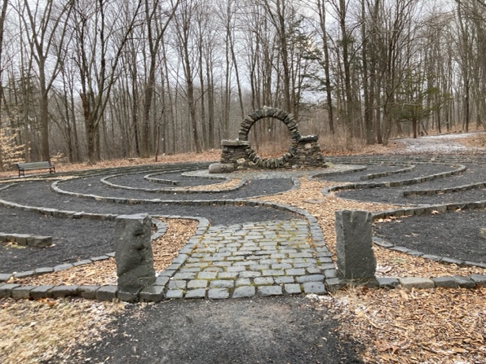

Medieval 6-circuit Abingdon style Labyrinth,

Holy Family Passionist Retreat Center, West Hartford, CT

Medieval 8-circuit Labyrinth, Sprague

Elementary School, Wellesley, MA

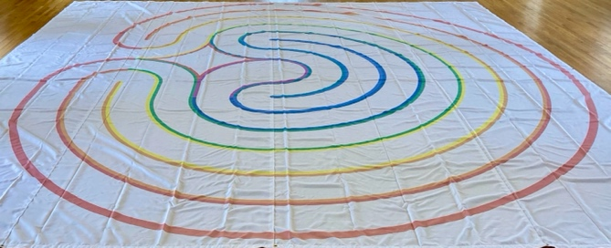

Classical 7-circuit floor cloth Labyrinth,

Storrs Congregational Church, Storrs, CT

Medieval 11- circuit Labyrinth, Block Island, RI

A Classical design, wooden handheld Labyrinth

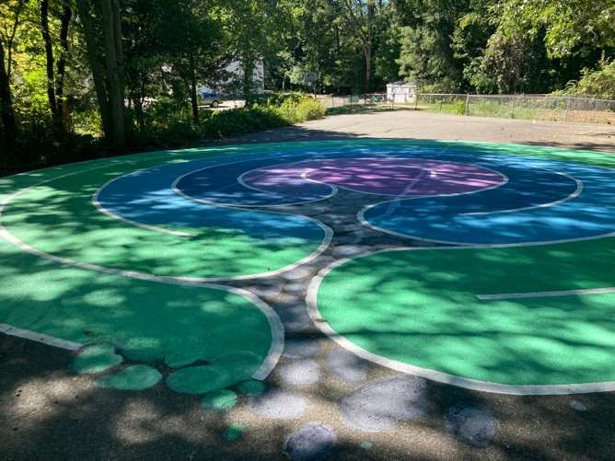

A contemporary Labyrinth at Weston United

Methodist Church in Weston, MA

Resources:

To find a Labyrinth near you to walk: [www.labyrinthlocator.com](http://www.labyrinthlocator.com)

For online Handheld Finger Labyrinth Meditations:www.veriditas.org

Books:

Anderson, C. (2018). *Meeting Your Soul on the Labyrinth*. Creative Pilgrimage Press.

Artress, L. (2006). *The sacred path companion: A guide to walking the labyrinth to heal and transform*. Riverhead Books.

Artress, L. (2006). *Walking a Sacred Path: Rediscovering the Labyrinth as a Spiritual Practice*. Riverhead Books.

Artress, L. (2020). *The Path of the Holy Fool: How the Labyrinth Ignites Our Visionary Powers.* Rose Petal Press.

Ferré, R. (2013). *Church Labyrinths: Questions & answers regarding the history, relevance, and use of labyrinths in churches.* Labyrinth Enterprises, LLC.

Hartwell Geoffrion, J. K. and Nagel, E. C. (2001). *The Labyrinth and the Enneagram: Circling into Prayer*. The Pilgrim Press.

Hartwell Geoffrion, J. K. (1999). *Praying the Labyrinth: A Journal for Spiritual Exploration.* The Pilgrim Press.

MacQueen, Gailand. (2021). *Celebrating the Labyrinth: A Journey of the Spirit.* Wood Lake Publishing.

Ng, Diana. (2015). *Walking the Labyrinth: Your Path to Peace and Possi*bilities. KaDa Publishing.

Raphael Sands, H. (2000). *Labyrinth: Pathway to meditation and healing*. Gaia Books Limited.

Sanna, E. and McIntonsh, K. (2012). *The Labyrinth: a spiritual journey*. Anamchara Books.

**Mandala Meditation**

**Mandala**

* Pronounced: Mon- dah- lah
* It means “circle”
* Represents wholeness; as in a cosmic diagram that reminds us of our relation to infinity, extending beyond and within our own bodies and mind
* Are used for meditation and prayer purposes; to allow the person to become one with the universe
* The symbolism of mandalas are meaningful to people in almost any faith tradition
* A labyrinth is a mandala; the center of which represents the heart of God.
* Stained glass windows are often patterns like mandalas.

Isaiah 49:13-16 (New Revised Standard Version Updated Edition)

**13**Sing for joy, O heavens, and exult, O earth;  
    break forth, O mountains, into singing!  
For the Lord has comforted his people  
    and will have compassion on his suffering ones.

**14**But Zion said, “The Lord has forsaken me;  
    my Lord has forgotten me.”  
**15**Can a woman forget her nursing child  
    or show no compassion for the child of her womb?  
Even these might forget,  
    yet I will not forget you.  
**16**See, I have inscribed you on the palms of my hands;  
    your walls are continually before me.

**Legume Mandalas**

Create mandalas with the dried beans, peas and corn!

**From one legume Mandala creator:** *“I spread everything out to place the legumes on the backing, not gluing them yet but just trying to create a pattern. At first, I was amused and felt like I was a kid again— making a macaroni picture. And I was thinking about other things and feeling pretty stressed in general…this turned out to be* ***just what I needed****, because soon a pattern began to form as I began gluing each tiny legume, using tweezers for the smallest ones, and I started to concentrate and began to really feel a calmness from the careful, repetitive, and intentional work and seeing the pattern as it evolved.*

*I noticed that* ***my breath and heart rate began to match the slow and patient*** *tempo of the creating. As I entered this relaxation, I also began to experience a* ***heightened sense of clarity*** *and I realized that none of the legumes would look bad anywhere I glued them. Even if they had differences, they all matched or contrasted in various ways for a unified and compatible existence no matter where they were placed, sort of like how an ideal universe would look like for us, too.”*~Ellen

**Mandalas to Color**

Print and color mandalas at home: [Mandala Coloring Pages for Adults & Kids](https://www.happinessishomemade.net/mandala-coloring-pages/)

& [Free Printable Mandala Coloring Pages For Kids](https://coloringhome.com/free-printable-mandala-coloring-pages-for-kids)

Meditative Music video to listen while you create:

[BE STILL - 1 Hour Peaceful & Relaxing Music | Christian Meditation Music | Prayer & Worship Music](https://www.youtube.com/watch?v=A5r9skkZtN0)

Skyhorse Pub Co Inc. (2015). *Mandalas: Coloring for everyone*.

**Praying in Color**

Praying in color can take any form. You might start with a plain white sheet of paper, a sketch pad, or perhaps you might prefer an outline to color within the lines. The first time I experienced this form of prayer was at a family church camp weekend. Each family was given a sketch pad and coloring pencils. Each day we were given a prompt for our family members to color prayers for one another.

The doodle coloring above is an example of praying in color—while participating with an online church service, I used coloring pencils, for my doodling, making circular bubbles around the page. In each bubble, I lifted prayers for each participant as I added the name(s) who were in each Zoom window.

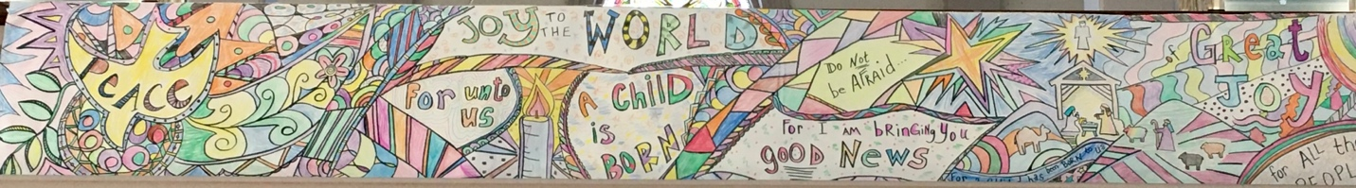

This long banner above was part of an intergenerational Advent festival for all ages to join in conversation to share hopes and dreams while coloring. It was displayed for all to see

Resources:

Sybil MacBeth, *Praying in Color: Drawing a New Path to God.* Paraclete Press, 2013.

Sybil MacBeth, *Pray and Color: A Coloring Book and Guide to Prayer*. Paraclete Press, 2016.

Sybil MacBeth, *Praying in Color Kid’s Edition*. Paraclete Press, 2009.